**DAILY ONLINE ACTIVITIES SUMMARY**

|  |  |  |  |  |  |  |  |  |
| --- | --- | --- | --- | --- | --- | --- | --- | --- |
| **Date:** | **09/06/2020** | | | | | **Name:** | **AKASH S** | |
| **Sem & Sec** | **4TH&A** | | | | | **USN:** | **4AL18CS004** | |
| **Online Test Summary** | | | | | | | | |
| **Subject** | | **---** | | | | | | |
| **Max. Marks** | | **-** | | **Score** | | | **-** | |
| **Certification Course Summary** | | | | | | | | |
| **Course** | **INTRODUCTION TO DIGITAL MARKETING** | | | | | | | |
| **Certificate Provider** | | | **GREAT LEARNING** | | **Duration** | | | **2.5 HOURS** |
| **Coding Challenges** | | | | | | | | |
| **Problem Statement 1: Write a C Program to rotate the matrix by K times Program in C** | | | | | | | | |
| **Status: executed** | | | | | | | | |
| **Uploaded the report in Github** | | | | | **YES** | | | |
| **If yes Repository name** | | | | | <https://github.com/akashacharya786/lockdown-c-coding>  **https://github.com/akashacharya786/lockdown-java-coding** | | | |
| **Uploaded the report in slack** | | | | | **YES** | | | |

Online Test Summary:

**Online Certification course:**

Name of the course : Introduction to digital marketing

Duration: 2.5 hours

Certificate provider: great learning

Today I have successfully completed Introduction to digital marketing . I have written a assessment quiz and successfully received the certificate

Snap shot:

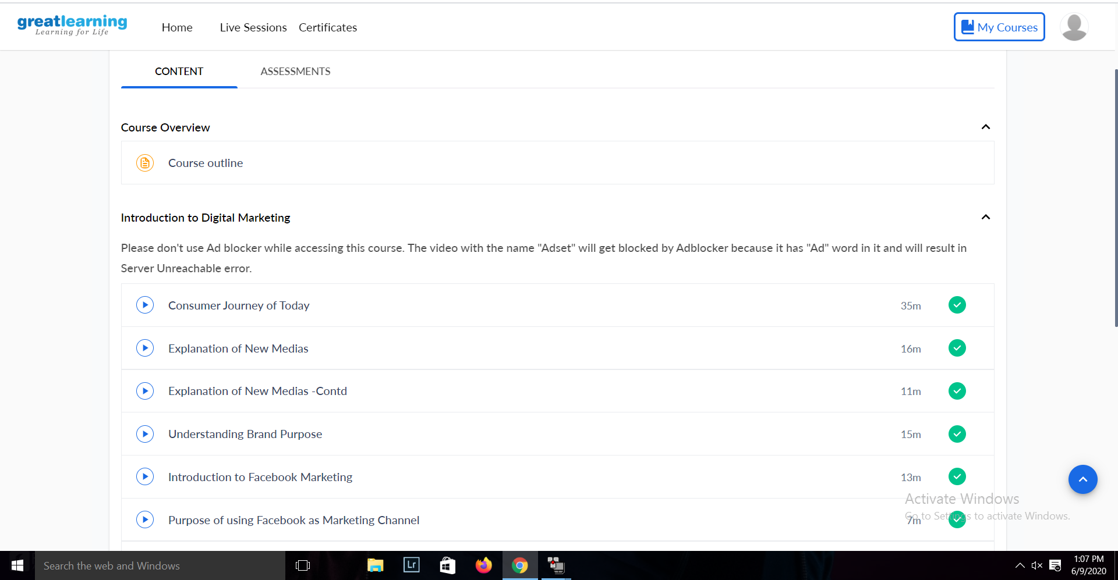

Online Coding summary:

**1.   Write a C Program to rotate the matrix by K times Program in C**

